Jackson Warren

Jeremy Bergen

CSCI 370

12/6/21

Lab 12

Section 1:

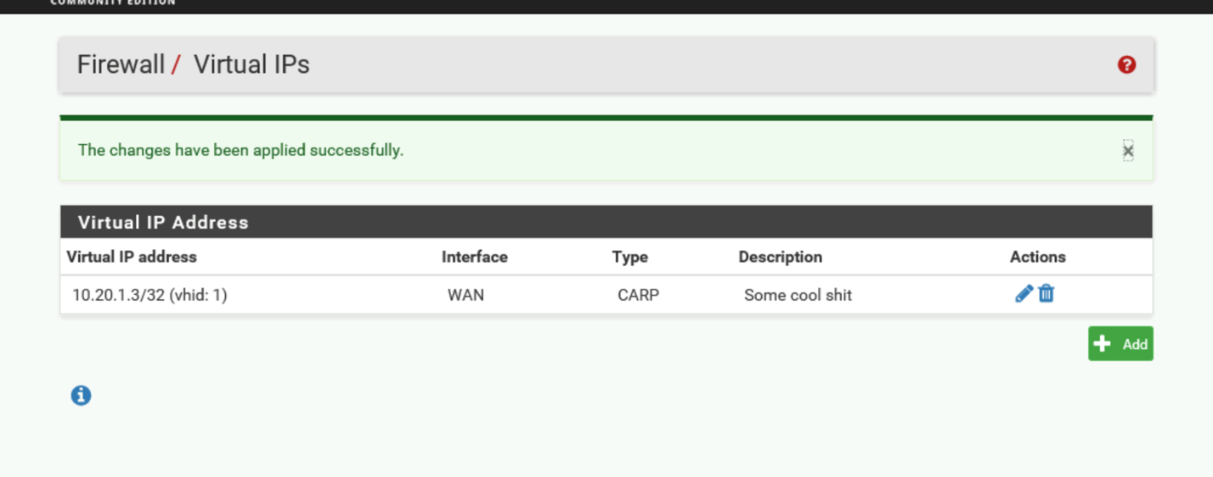

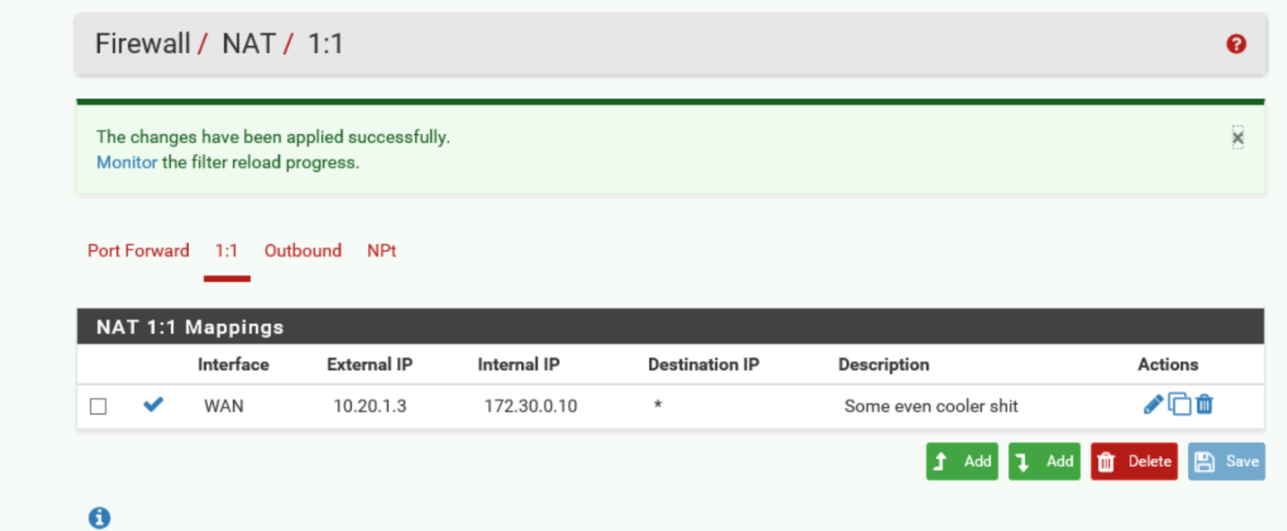

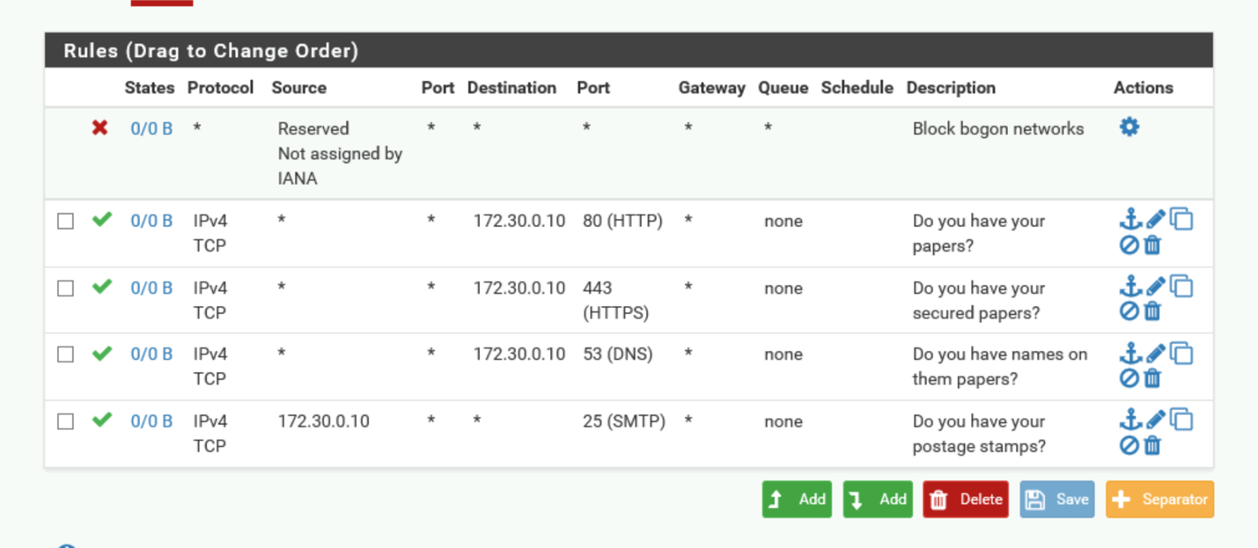

Section 2:

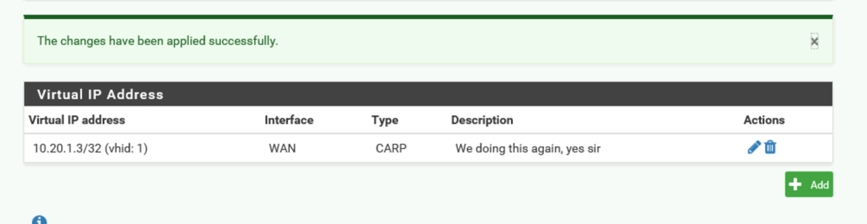

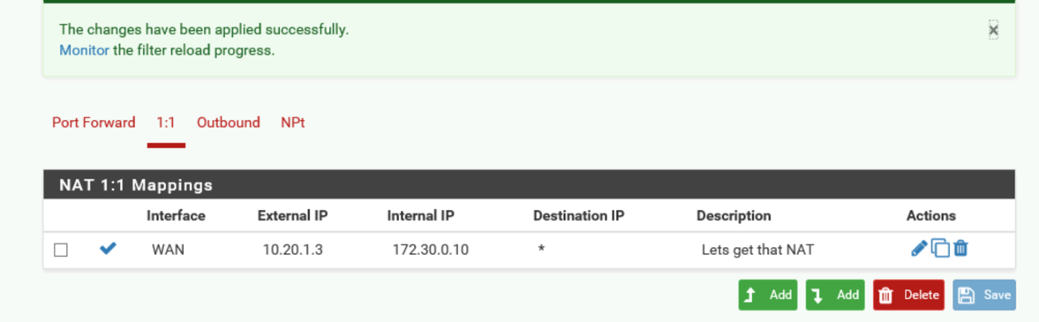

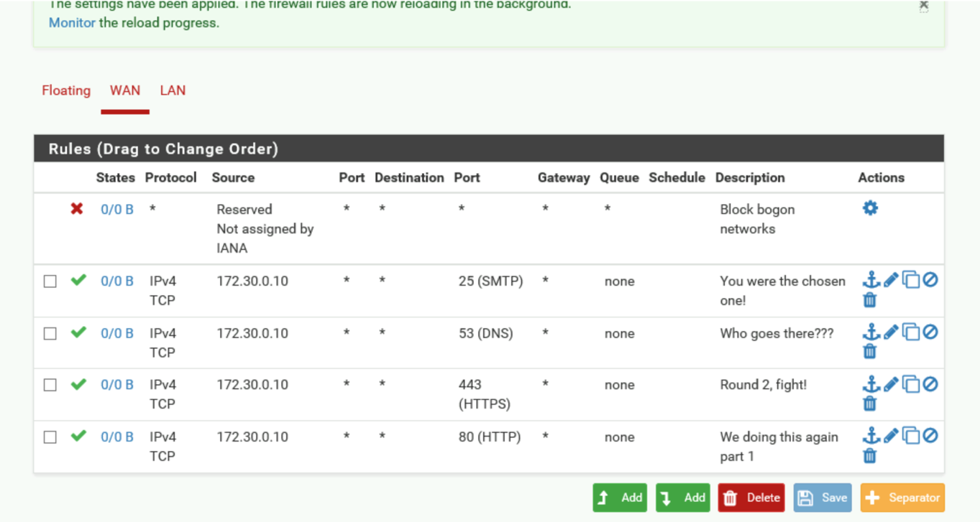

Ok, so for the next part my TagertWindows01 would not open. Tried it several times and it’s not working for some reason. I tried continuing the lab on the second server but the addresses are different and didn’t work when trying to then load that page. 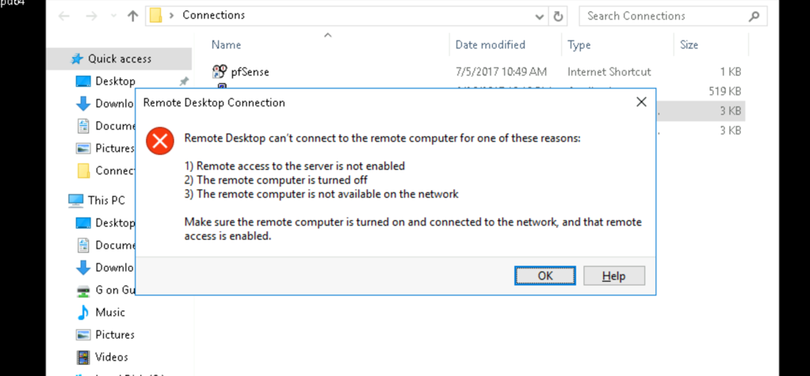

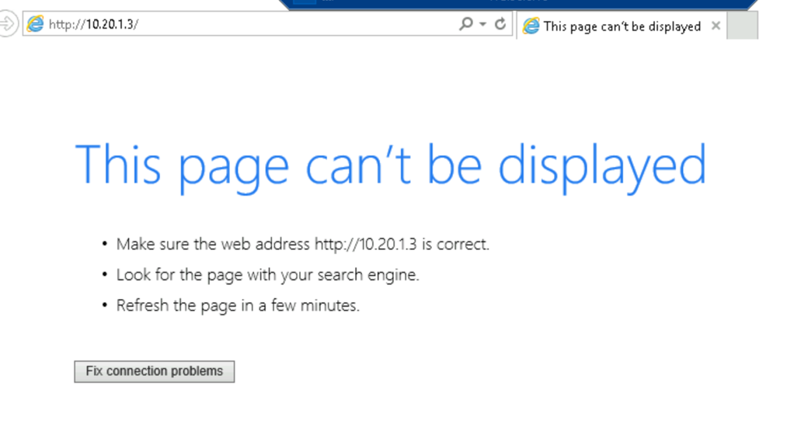

Section 3:

Part 1: Security through obscurity is mostly the meaning of creating security by removing the potential of gaining personal info by bombarding those searching with other irrelevant things, essentially creating security by making it harder to actually dig and find the important info. NAT really provides no security whatsoever. It can provide a firewall and assist in this “security through obscurity”, but beyond obscuring the internal network, it does not aid much beyond this.

Part 2: I could not figure out this for the life of me. I kept getting errors for some reason and just gave up after a while. Not sure if this has to do with the target windows 01 not working but I couldn’t make it happen.

Part 3: 